**Output with scaling**

Label Latin Name ... Train Images Validation Images

0 n0 alouatta_palliata\t ... 131 26

1 n1 erythrocebus_patas\t ... 139 28

2 n2 cacajao_calvus\t ... 137 27

3 n3 macaca_fuscata\t ... 152 30

4 n4 cebuella_pygmea\t ... 131 26

5 n5 cebus_capucinus\t ... 141 28

6 n6 mico_argentatus\t ... 132 26

7 n7 saimiri_sciureus\t ... 142 28

8 n8 aotus_nigriceps\t ... 133 27

9 n9 trachypithecus_johnii ... 132 26

[10 rows x 5 columns]

0 mantled_howler

1 patas_monkey

2 bald_uakari

3 japanese_macaque

4 pygmy_marmoset

5 white_headed_capuchin

6 silvery_marmoset

7 common_squirrel_monkey

8 black_headed_night_monkey

9 nilgiri_langur

Name: Common Name, dtype: object

Found 1098 images belonging to 10 classes.

Found 272 images belonging to 10 classes.

pygmy_marmoset

/content/drive/My Drive/training/training/n4

n4017.jpg

(864, 1300, 3)

n4

/content/drive/My Drive/training/training/n4

n4128.jpg

(630, 750, 3)

n4

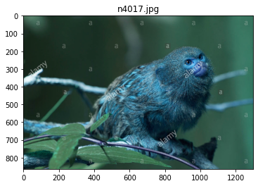

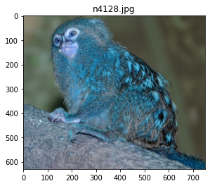

Train on 1098 samples, validate on 272 samples

Epoch 1/25

1098/1098 [==============================] - 1s 458us/step - loss: 2.3089 - accuracy: 0.1157 - val_loss: 2.3076 - val_accuracy: 0.0956

Epoch 2/25

1098/1098 [==============================] - 0s 231us/step - loss: 2.2251 - accuracy: 0.1566 - val_loss: 2.4245 - val_accuracy: 0.0588

Epoch 3/25

1098/1098 [==============================] - 0s 215us/step - loss: 2.1245 - accuracy: 0.2650 - val_loss: 2.3468 - val_accuracy: 0.0956

Epoch 4/25

1098/1098 [==============================] - 0s 219us/step - loss: 2.0806 - accuracy: 0.2814 - val_loss: 2.3814 - val_accuracy: 0.0919

Epoch 5/25

1098/1098 [==============================] - 0s 212us/step - loss: 1.9605 - accuracy: 0.3015 - val_loss: 2.4412 - val_accuracy: 0.0551

Epoch 6/25

1098/1098 [==============================] - 0s 223us/step - loss: 1.8521 - accuracy: 0.3434 - val_loss: 2.6551 - val_accuracy: 0.0772

Epoch 7/25

1098/1098 [==============================] - 0s 210us/step - loss: 1.7974 - accuracy: 0.3725 - val_loss: 2.4032 - val_accuracy: 0.1066

Epoch 8/25

1098/1098 [==============================] - 0s 217us/step - loss: 1.7745 - accuracy: 0.3707 - val_loss: 2.6593 - val_accuracy: 0.0515

Epoch 9/25

1098/1098 [==============================] - 0s 209us/step - loss: 1.6379 - accuracy: 0.4362 - val_loss: 2.7417 - val_accuracy: 0.0735

Epoch 10/25

1098/1098 [==============================] - 0s 217us/step - loss: 1.6034 - accuracy: 0.4417 - val_loss: 2.8777 - val_accuracy: 0.0809

Epoch 11/25

1098/1098 [==============================] - 0s 216us/step - loss: 1.5160 - accuracy: 0.4781 - val_loss: 3.2072 - val_accuracy: 0.0956

Epoch 12/25

1098/1098 [==============================] - 0s 214us/step - loss: 1.4019 - accuracy: 0.5100 - val_loss: 3.1813 - val_accuracy: 0.0919

Epoch 13/25

1098/1098 [==============================] - 0s 210us/step - loss: 1.3304 - accuracy: 0.5437 - val_loss: 3.2722 - val_accuracy: 0.0588

Epoch 14/25

1098/1098 [==============================] - 0s 220us/step - loss: 1.3698 - accuracy: 0.5264 - val_loss: 3.0590 - val_accuracy: 0.0846

Epoch 15/25

1098/1098 [==============================] - 0s 215us/step - loss: 1.1872 - accuracy: 0.6029 - val_loss: 3.7364 - val_accuracy: 0.0735

Epoch 16/25

1098/1098 [==============================] - 0s 219us/step - loss: 1.0612 - accuracy: 0.6339 - val_loss: 3.5233 - val_accuracy: 0.0809

Epoch 17/25

1098/1098 [==============================] - 0s 214us/step - loss: 0.8748 - accuracy: 0.6922 - val_loss: 4.2359 - val_accuracy: 0.0551

Epoch 18/25

1098/1098 [==============================] - 0s 222us/step - loss: 0.7922 - accuracy: 0.7432 - val_loss: 4.5457 - val_accuracy: 0.0404

Epoch 19/25

1098/1098 [==============================] - 0s 210us/step - loss: 0.6836 - accuracy: 0.7614 - val_loss: 5.2882 - val_accuracy: 0.0404

Epoch 20/25

1098/1098 [==============================] - 0s 224us/step - loss: 0.6143 - accuracy: 0.7951 - val_loss: 4.8509 - val_accuracy: 0.0551

Epoch 21/25

1098/1098 [==============================] - 0s 232us/step - loss: 0.6174 - accuracy: 0.7869 - val_loss: 5.3777 - val_accuracy: 0.0441

Epoch 22/25

1098/1098 [==============================] - 0s 211us/step - loss: 0.4774 - accuracy: 0.8388 - val_loss: 5.5096 - val_accuracy: 0.0478

Epoch 23/25

1098/1098 [==============================] - 0s 213us/step - loss: 0.4261 - accuracy: 0.8588 - val_loss: 6.9943 - val_accuracy: 0.0478

Epoch 24/25

1098/1098 [==============================] - 0s 210us/step - loss: 0.3445 - accuracy: 0.8852 - val_loss: 6.5396 - val_accuracy: 0.0478

Epoch 25/25

1098/1098 [==============================] - 0s 219us/step - loss: 0.3297 - accuracy: 0.8770 - val_loss: 6.3164 - val_accuracy: 0.0662

Model: "sequential_8"

_________________________________________________________________

Layer (type) Output Shape Param #

=================================================================

conv2d_29 (Conv2D) (None, 32, 32, 32) 896

_________________________________________________________________

dropout_22 (Dropout) (None, 32, 32, 32) 0

_________________________________________________________________

conv2d_30 (Conv2D) (None, 32, 32, 32) 9248

_________________________________________________________________

max_pooling2d_15 (MaxPooling (None, 16, 16, 32) 0

_________________________________________________________________

conv2d_31 (Conv2D) (None, 16, 16, 64) 18496

_________________________________________________________________

dropout_23 (Dropout) (None, 16, 16, 64) 0

_________________________________________________________________

conv2d_32 (Conv2D) (None, 16, 16, 64) 36928

_________________________________________________________________

max_pooling2d_16 (MaxPooling (None, 8, 8, 64) 0

_________________________________________________________________

flatten_8 (Flatten) (None, 4096) 0

_________________________________________________________________

dense_15 (Dense) (None, 512) 2097664

_________________________________________________________________

dropout_24 (Dropout) (None, 512) 0

_________________________________________________________________

dense_16 (Dense) (None, 10) 5130

=================================================================

Total params: 2,168,362

Trainable params: 2,168,362

Non-trainable params: 0

_________________________________________________________________

None

dict_keys(['val_loss', 'val_accuracy', 'loss', 'accuracy'])

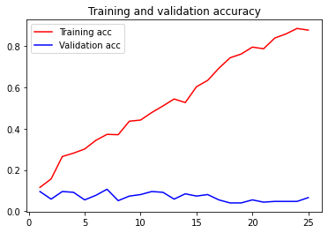

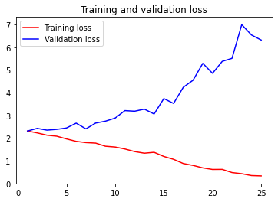

Model: "sequential_8"

_________________________________________________________________

Layer (type) Output Shape Param #

=================================================================

conv2d_29 (Conv2D) (None, 32, 32, 32) 896

_________________________________________________________________

dropout_22 (Dropout) (None, 32, 32, 32) 0

_________________________________________________________________

conv2d_30 (Conv2D) (None, 32, 32, 32) 9248

_________________________________________________________________

max_pooling2d_15 (MaxPooling (None, 16, 16, 32) 0

_________________________________________________________________

conv2d_31 (Conv2D) (None, 16, 16, 64) 18496

_________________________________________________________________

dropout_23 (Dropout) (None, 16, 16, 64) 0

_________________________________________________________________

conv2d_32 (Conv2D) (None, 16, 16, 64) 36928

_________________________________________________________________

max_pooling2d_16 (MaxPooling (None, 8, 8, 64) 0

_________________________________________________________________

flatten_8 (Flatten) (None, 4096) 0

_________________________________________________________________

dense_15 (Dense) (None, 512) 2097664

_________________________________________________________________

dropout_24 (Dropout) (None, 512) 0

_________________________________________________________________

dense_16 (Dense) (None, 10) 5130

=================================================================

Total params: 2,168,362

Trainable params: 2,168,362

Non-trainable params: 0

_________________________________________________________________

None

Loss: 6.316435084623449

Accuracy: 0.06617647409439087

